QUARANTINE PERENNIAL FOOTBALL LEAGUE STANDINGS
Vol. I, No. 17 - 12/29/2020
Team | Rank Points | Wins | Losses | Top Half | Points For
Sandusky’s Secret - CWR* | 15 | 7 | 7 | 8 | 1137
The Mixon Administration - GSA* | 17 | 9 | 5 | 8 | 1428
Josh Allen’s Deleted Tweets - CGK* | 17.5 | 8.5 | 5.5 | 9 | 1324
The Midlife Existential Crisis - AYP* | 15.5 | 7.5 | 6.5 | 8 | 1205
The One Percenters - WJK^ | 14 | 8 | 6 | 6 | 1132
Suspended for Inactivity - JRW^ | 12 | 7 | 7 | 5 | 1081
War Crimes for Reagan - RCP^ | 10 | 5 | 9 | 5 | 1272
KiloCorp - MPA^ | 10 | 4 | 10 | 6 | 1180

1st Annual QPFL Championship
(4) Sandusky’s Secret 78, (2) The Mixon Administration 75

Consolation Cup
(1) Josh Allen’s Deleted Tweets 135, (3) The Midlife Existential Crisis 104

Punishment
Miles had to take a Mandarin fluency test. He failed.

Jambo Rankings
KiloCorp - 193
War Crimes for Reagan - 185
The One Percenters - 181
Suspended for Inactivity - 179

League Information
Congratulations to everyone for finishing the QPFL’s first season! I hope this was a fun experience, and that this can be the first of many years of fun, memes, and fantasy football.

Draft Status and Trading
The 2021 QPFL draft is the next league event, and will be held during the NFL preseason next year. The order, with all traded picks applied, can be viewed here. Traded picks list can be viewed here. Trading is now open. Have fun! You can view current rosters here.

Payment for next season
I hope everyone had a good time and wants to return for QPFL season 2. If you do, the buy in will remain $20. You can view a list of who has paid here. I’ve applied this year’s winnings to payment for next season. If you don’t want me to do that, just shoot me a text. My venmo is @GriffinAnsel for those that haven’t paid.

Rules Feedback
If you would like to give me some rules feedback, here is a form where you can do so. I will compile a list of these and we will review before next season. You can also shoot me a text/email/groupme.

Playoff Pick Em
Below are the rules for the playoff pick em. Venmo me $5 to secure your spot, 4 person minimum to make this happen. I think it’ll be a blast. Text me with questions.
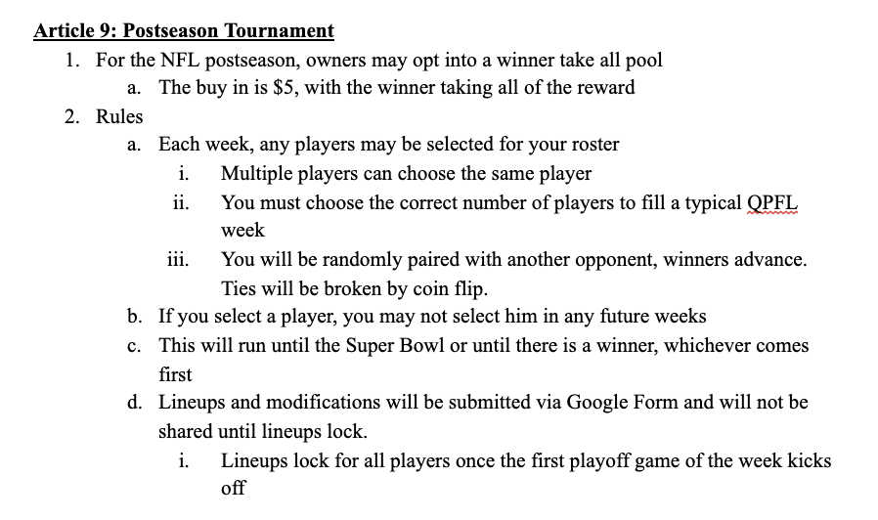
MVP Race
First, huge congratulations to our inaugural champion: Connor! Congrats as well to Miles for winning the Jambo, proving that the playoffs are a new beast when it comes to scoring! The office of the commissioner is sponsoring an MVP award. The owner who’s team has the league MVP wins the prize: 1 beer, provided by me, whenever I have the chance. I have nominated the player I feel was the best performer of each team, and will send a groupme poll shortly after this email. Please vote based on who you think provided the most value to their franchise. The nominees are:

RB Dalvin Cook (GSA)
TE Travis Kelce (CGK)
WR Justin Jefferson (MPA)
WR Davante Adams (AYP)
QB Aaron Rodgers (WJK)
RB Nick Chubb (CWR)
RB Aaron Jones (JRW)
RB Derrick Henry (RCP)

Quick Takes
Championship
Fuck. That’s all I have to say. Connor earned this one by a margin much larger than the score suggests, as WR Stefon Diggs ate the undermanned Patriots secondary for breakfast after the ship had been locked up. Well earned, Connor, and congrats on stealing your name back.

Toilet Bowl
Arnav made it interesting as Davante did Davante things, but Kaminska, in a year he sold out for the championship, rode Josh Allen to 3rd place. Ouch.

Jambo
It’s interesting how the Jambo takes a different form from the rest of the year, becoming a two week scoring fest that anybody could win. Bocki’s juggernaut came up close, but ultimately fell to the more consistent KiloCorp, who won despite a last place finish. Fun stuff for sure.

